**DAILY ONLINE ACTIVITIES SUMMARY**

|  |  |  |  |  |  |  |  |  |
| --- | --- | --- | --- | --- | --- | --- | --- | --- |
| **Date:** | **04-06-2020** | | | | | **Name:** | **Raksha S** | |
| **Sem & Sec** | **6th B** | | | | | **USN:** | **4AL17CS073** | |
| **Online Test Summary** | | | | | | | | |
| **Subject** | | **OS** | | | | | | |
| **Max. Marks** | | **30** | | **Score** | | | **17** | |
| **Certification Course Summary** | | | | | | | | |
| **Course** | **FullStack Webdevelopment** | | | | | | | |
| **Certificate Provider** | | | **Greatlearning** | | **Duration** | | | **45 days** |
| **Coding Challenges** | | | | | | | | |
| Problem Statement: 1. Java program to left rotate the elements of an array.  2. C program to find leader in array. | | | | | | | | |
| **Status:** YES, Completed all Programs | | | | | | | | |
| **Uploaded the report in Github** | | | | | **YES** | | | |
| **If yes Repository name** | | | | | <https://github.com/raksha05/Daily-Status>/Raksha-4AL17CS073/Raksha | | | |
| **Uploaded the report in slack** | | | | | **YES** | | | |

Online Test Details:

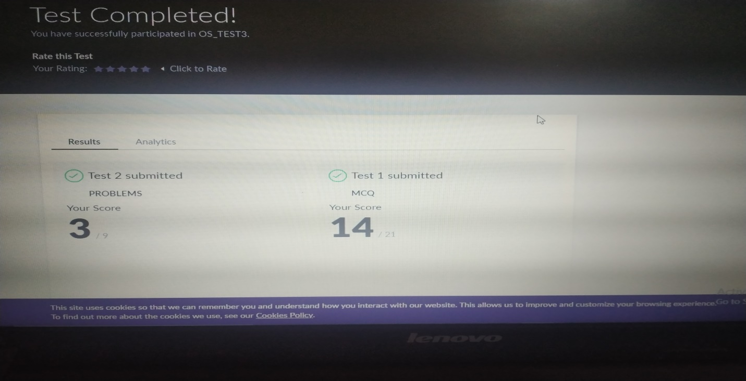

Scored 17 out of 30 in Python Assignment test

Certification Course Details:

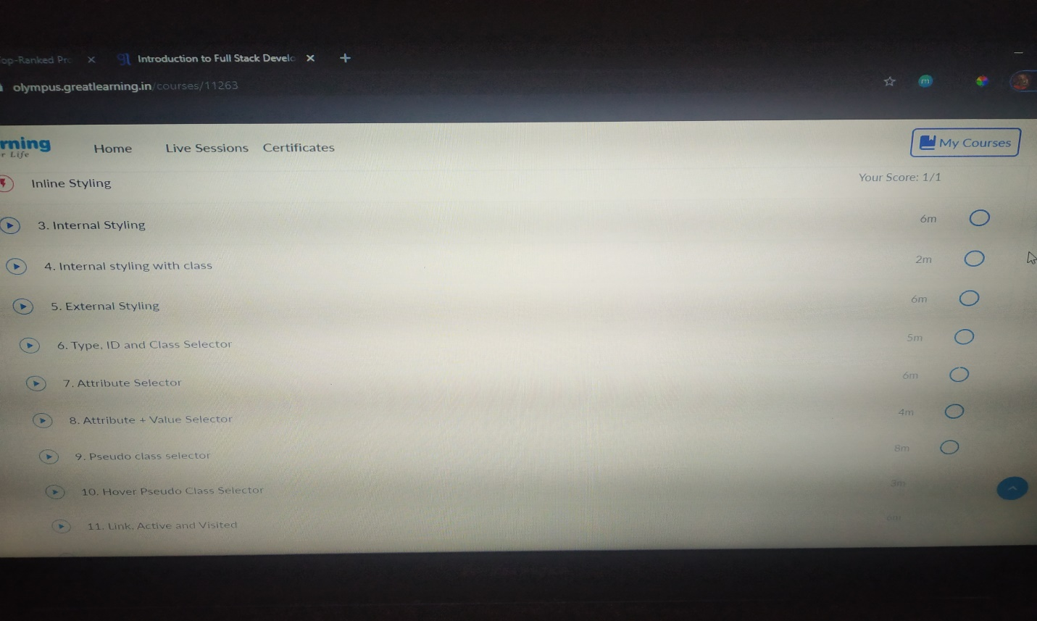

**The above certification course is based on FullStack Webdevelopment.Today I have learnt about selectors,attribute selector,value selector,pseudo selector,class selector,its uses and applications.**

Coding Challenges Details:

Program1:

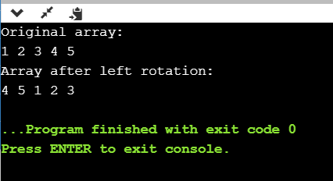

Program2:

